

School of Public Administration  
Bachelor of Science in Computing

**COMP492Final Year Project  
Progress Report**Academic Year 2014/15

|  |  |
| --- | --- |
| Experiment with Lego Robot as an Indoor Helper | |
|  |  |
| Project number: | 29 |
| Student ID: | p1107923 |
| Student Name: | Key, Liang Yijuan |
|  |  |
| Supervisor: | Dr. Cora Lai |
| Assessor: | Dr. CT Lam |
|  |  |
| Submission Date: | **2014/10/23** |

Declaration of Originality

I, Liang Yijuan, declare that this report and the work reported here in was composed by and originated entirely from me. This report has not been submitted in any form for another degree or diploma at any university or other institute of tertiary education. Information derived from the published and unpublished work of others has been acknowledged in the text and a list of references is given in the bibliography.



Abstract

The primary purpose this project is to develop and control an indoor navigation robot which can go to a desired place within a room area and do the delivery as a helper. The experiment will be made with the Lego Mindstorms EV3 robot and indoor positioning with Radio Frequency Identification (RFID) and landmark recognition technology are used in the project. A month was spent to analyse how other studies do navigation with different robots. Different localization approach suggested by other research will be experimented with the LEGO robot which the hardware is not built up by the author of the project. Also, an Android application will be developed to assist the robot in reading the RFID tags.

In this project, the following functions will be included. Firstly, the robot could move following the landmark. Secondly, the robot could read RFID tags to get its location and some related information. Thirdly, moving path should be calculated according to the Dijkstra's algorithm. Lastly, the robot could deliver some objects like markers, erasers, or lecture notes etc to a desired location.

Acknowledgement

I want to express my greatest appreciation to my project supervisor Dr. Cora Lai. She spent a lot of effort to help me with my project and writing. I also want to say thank you to Prof. Giovanni Pauand Prof. Rita Tse for their biggest support for providing the hardware. Without the above three people, I could not image the project would develop to the final stage.

Table of Contents

1 Introduction 5

1.1 Objectives 5

1.2 Summary 6

1.3 Risk Assessment 6

2 Background and Related Work 7

References 9

Appendix A. Project management 10

# Introduction

In the last two decades, a lot of experiments were made with the robots. Evidences could be found such as a fuzzy logic control robot [1], indoor mobile robots with color landmark recognition [2], a robot equipped RFID for navigation [4]. This project will try to replicate the experiments approaches of other projects using Lego EV3 robot that is not designed by the author. ??

The robot will be controlled by the computer through Bluetooth. And color sensor and RFID will be used for localization. As confined by the Bluetooth signal range, the robot in this project will move in room A322 in MPI but cannot move around the whole floor. In the very beginning, this EV3 robot will move on a whiteboard following color landmarks drawn with highlight pens.

## Objectives

The main task of this project is to develop and control an indoor navigation robot which can go to a desired place within a room area and do the delivery as a helper. This robot can move following the color line and fetch objects and do delivery. LEGO® MINDSTORMS® EV3 is chosen as the development model.

The following functions should be developed with the robot in this project:

* Move from starting position to different destinations
* Move according color lines
* Turn left or right correctly
* Go back to start area after reaching the destination
* Read Near Field Communication (NFC) tags to recognize places
* Deliver objects to the destination

## Summary

This report is organized as follows: Chapter 1 gives some background introduction of the project. Objectives will be also listed in this chapter. Chapter2 introduces the background of our work.

## Risk Assessment

During the process, there are four possible risks may occurs, namely battery running out, connection setup disabled, hard disk damage and data lost and motor out of function.

Firstly, there is a potential risk that battery runs out during the testing period. This will lead the robot move in a shorter distance as expect. Also, as movement is controlled by the motor power volume, so if the battery is almost run out and cannot provide enough power for moving distance as the design. Therefore, full-charged backup batteries are prepared.

Secondly, as there are too much radio signals in the campus, Bluetooth connection may be interfered. This makes it impossible to set up the connection between the computer and the robot. If this happens, it is tested to be feasible to move to another place, for example the rooftop, to reset the connection. The connection set up process can be performed at the rooftop of the teaching building, as there is less interferes. Once the connection is set up it will not be disconnected until disconnect operation is triggered, and after connection set up, everything can be move back to the lab and resume its normal operation.

Thirdly, all the develop programs or documents may lost due to hard disk problem. Therefore, besides saving data in the local computer, at least one copy backup will be placed in a USB and a backup copy will be put in the network. Once development data is lost, backup data will be used to continue the project. Furthermore, all files of the every process will have at least one backup copy so that the project can go back at any time.

Last but not least, In case of accident, motor of the robot may be out of function. This might stop the robot from moving. If this happen, it is necessary to replace motor with a backup that is in place.

# Background and Related Work

This section will give some background about robots and robot navigation first. And then will introduction two navigation approaches (RFID and landmark recognition) in the later paragraphs.

## Robots

As the development of technology, human robot interaction development has been a big topic in the world. A lot of experiments were made by different studies. In those studies, some used a robot developed by the author themselves and some used a robot provide in the market. Although using robot develop by the authors could meet the needs of the experiment directly but it may also lead to problems like requiring a huge cost or the knowledge of the author about robotics [7]. However, using robots models provided in the market could solve those problems. Lego Mindstorms programmable robot is one of the models widely selected for robot experiments. The reason why Lego Mindstorms is widely chosen for experiments is due to cost, flexibility, student interest and professional curiosity [7].

## Robot Navigation

There is no doubt that robot navigation has become one of the biggest topics in the world.A lot of studies could be found doing this topic. For instance, Tripathy H.K. et al. presented a prospective fuzzy logic approach for robot navigation [3]. Also, Hahnel D. et al. experimented the robot navigation using RFID [4]. Moreover, using color landmark to do the self-localization for robot navigation was done by Gijeong J. et al. [2]. RFID and landmark recognition are the two most common technologies used in robot navigation. More information about these two technologies will be discussed in the next two paragraphs.

## Robot Navigation

RFID is a technology that enables identification different tags in a range [8]. In each tags different information (unique ID, location, text, etc.) can be stored inside. Reader can recognize the tag without and contact. Therefore, it is widely used with mobile robot for navigation since the last decade [3]. Tasks like navigation, localization and mapping can be done with information inside RFID tags [4]. Evidences can be easy found in many projects. For example, Gueaieb, W and Miah Md.S. presented an intelligent novel non-vision-based robot using RFID technology [5]. In the whole project three stages of experiments was shown. The robot was firstly tried to move following a line segment, and then tried to move following a complex path. After successfully try with the two approaches and then the third experiment—moving following tags singles from the hallway is done successfully. This develop processes will be also emulated in this project. Besides, HyungSoo L et al. presented an indoor robot using an efficient RFID system which a scheme for the efficient localization is designed [9]. RFID tags with absolute position information were attached on the floor for localization in the project.

## Robot Navigation

Another widely used technology for robot navigation is read the landmark from the environment. A mobile robot read the landmark with a gray-scale camera form a known environment is developed by Hallmann and Siemiatkowska[6]. In this project, information on a map of the environment to be tested is built inside. Landmarks were placed in specific locations to help with the navigation. And the built map is developed based on information feedback from the sensors. This is a combination of using both a sensor and landmark for robot localization.

References

[1] Azlan, N.Z.; Zainudin, F.; Yusuf, H.M.; Toha, S.F.; Yusoff, S.Z.S.; Osman, N.H., Fuzzy Logic Controlled Miniature LEGO Robot for Undergraduate Training System, Industrial Electronics and Applications, 2nd IEEE Conference on, vol., no., pp.2184, 2188, 23-25 May 2007

[2] Gijeong Jang; Sungho Lee; Inso Kweon, Color landmark based self-localization for indoor mobile robots, Robotics and Automation, Proceedings. ICRA '02. IEEE International Conference on, vol.1, no., 2002.

[3] Tripathy, H. K., Tripathy, B. K., & Das, P. K. A Prospective Fuzzy Logic approach to Knowledge-based Navigation of Mobile LEGO-Robot. Journal of Convergence Information Technology, 3(1), p64-70, 2008

[3] Klaus Finkenzeller. RFID Handboook: Radio-Frequency Identification Fundamentals and Applications. Wiley, New York, 2000.

[4] Hahnel, D.; Burgard, W.; Fox, D.; Fishkin, K.; Philipose, M., Mapping and localization with RFID technology, Robotics and Automation, 2004. Proceedings. ICRA '04. 2004 IEEE International Conference on, vol.1, no., pp.1015, 1020 Vol.1, 26 April-1 May 2004

[5] Gueaieb, W.; Miah, Md.S., An Intelligent Mobile Robot Navigation Technique Using RFID Technology, Instrumentation and Measurement, IEEE Transactions on , vol.57, no.9, pp.1908,1917, Sept. 2008

[6] I. Hallmann and B. Siemiatkowska, Artificial landmark navigation system, in Proc. Int. Symp. Intell. Robot. Syst., pp. 219–228, Jul. 2001.

[7] Klassner, F., & Anderson, S. D. Lego MindStorms: Not just for K-12 anymore. IEEE Robotics & Automation Magazine, 10(2), 12-18, 2003

[8] Want, R., An introduction to RFID technology, Pervasive Computing, IEEE, vol.5, no.1, pp.25, 33, Jan. March 2006

[9] HyungSoo Lim; ByoungSuk Choi; Jangmyung Lee, An Efficient Localization Algorithm for Mobile Robots based on RFID System, SICE-ICASE, International Joint Conference, vol., no., pp.5945, 5950, 18-21 Oct. 2006

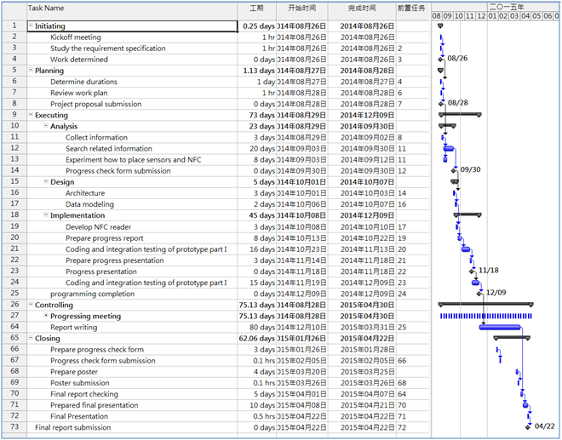Appendix A. Project management

Gantt chart, Project plan